AlphaMinds Web App - Final UI Direction
Please use the two attached screenshots as the visual reference. Keep the existing AlphaMinds design, fonts, spacing, colours and overall look. We are mainly changing the navigation, access levels and Home content.
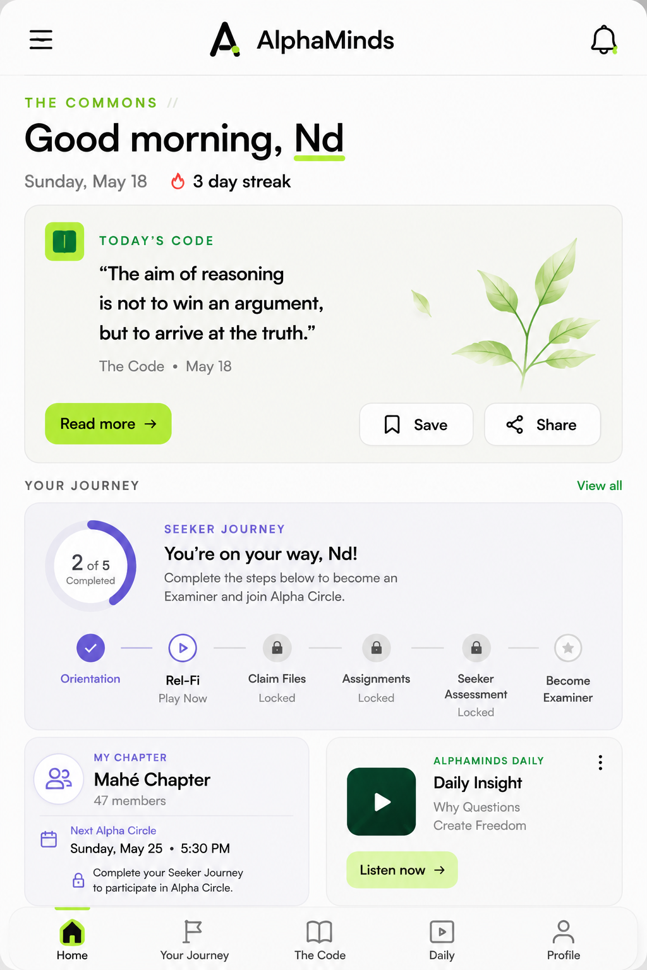

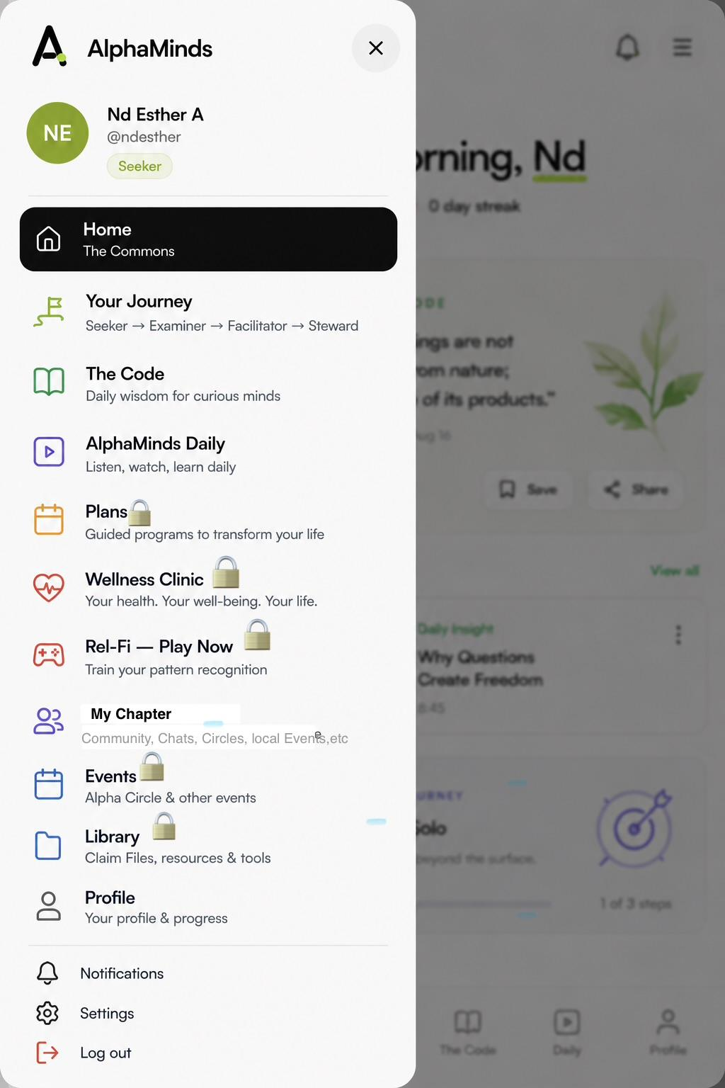

1. SIDEBAR
Replace the current Houses item with:

Your Journey
Seeker → Examiner → Facilitator → Steward
Add:

The Code
Daily knowledge & principles
Keep:

AlphaMinds Daily
Listen, watch, learn daily

Plans🔒
Guided programs

Wellness Clinic🔒

Future wellness/health destination

Rel-Fi — Play Now🔒
Locked for Seekers; becomes available for unrestricted play once the member becomes an Examiner.

My Chapter
The member’s selected physical Chapter.
Important: My Chapter is NOT locked. The member joins their Chapter during signup.

Events🔒
Alpha Circle & other events. Locked until the member completes the Seeker Journey and becomes an Examiner.

Library
Resources & tools.

Profile
Profile & progress.
Keep Notifications, Settings and Logout.

2. BOTTOM NAVIGATION
Keep it simple:
Home | Your Journey | The Code | Daily | Profile

3. HOME PAGE
Use the second screenshot as the reference.
Home should show:

Today’s Code
A daily passage from The Code.
Allow:
Read more | Save | Share
Then:

Your Journey
Show the member’s current progress.
For a new Seeker:
Orientation → Rel-Fi → Claim Files → Assignments → Seeker Assessment → Examiner
Only the current/available step is unlocked.
Then show:

My Chapter
Example:
Mahé Chapter
Show the next Alpha Circle, but if the member is still a Seeker:
🔒 Complete your Seeker Journey to participate in Alpha Circle.
Also show an AlphaMinds Daily card.

4. SEEKER ACCESS RULE
A new member becomes a Seeker after:
Signup → Email verification → Survey → Welcome.
They can access:
- The Code
- AlphaMinds Daily
- Their Journey
- Their assigned Seeker activities
- Their Chapter
But they cannot freely browse/play Rel-Fi yet.
Their journey must be completed in sequence:
Orientation
↓
Rel-Fi — Play Now
↓
Claim Files
↓
Required assignments
↓
Seeker Assessment
↓

EXAMINER

5. REL-FI
For a Seeker, Rel-Fi is part of the required journey.
Once they become an Examiner, the sidebar lock disappears:

🎮 Rel-Fi — Play Now
They can then play Rel-Fi whenever they want.
Please use “Play Now”, not “Play Rel-Fi” or “Start Game.”

6. CHAPTERS
The member’s Chapter is selected based on their real location.
They should not be able to randomly join a distant physical Chapter.
During signup:
Country → City → Area/location
Show nearby Chapters within the configured proximity radius.
Default radius: 15 km, but make this configurable by Admin.
If there is no suitable physical Chapter nearby:
No physical Chapter is currently available near you.

Join Virtual Alpha Circle
For now, members should not freely choose distant physical Chapters or multiple Chapters.
They have one primary Chapter.

7. ALPHA CIRCLE ACCESS
A member can belong to their Chapter as a Seeker, but cannot participate in its Alpha Circle yet.
After completing the Seeker Journey and becoming:

EXAMINER
Alpha Circle access unlocks.
Then their Chapter becomes their physical Alpha Circle community.
If there is no physical Chapter near their location, they use the Virtual Alpha Circle instead.

8. CHAPTER CREATION
Do not show “Create a Chapter” to everyone.
It should appear only when the member reaches the required leadership level, eventually Chapter Leader/Steward level, according to the permissions we define.
So this must be role/level controlled.

The main principle
Please don’t rebuild the whole UI.
Keep the current AlphaMinds design and implement the structure shown in these screenshots.
The key distinction is:
Your Journey = personal development
My Chapter = belonging
The Code = shared intellectual foundation
Rel-Fi — Play Now = reasoning game
Alpha Circle = deeper community participation
Plans = structured programs
Wellness Clinic = future wellness ecosystem
AlphaMinds Daily = daily content
The goal is a clean MVP that can start accepting Seekers while I continue adding the content progressively.

In Summary -

The Super Admin should be able to manage The MEMBERS’ JOURNEY.
Can upload Contents and manage access.

Please build the full Membership Journey structure into the app:
Seeker → Examiner → Facilitator → Steward → Chapter Leader → Chapter Coordinator
All levels should already exist in the system, but lock the next level until the member completes the required activities at their current level.

ADMIN CONTROL
From the Admin Dashboard, I should be able to:
- Select any level.
- Add a course, activity, assignment, quiz, assessment, Rel-Fi, Claim File, etc.
- Arrange the activities in the order I want.
- Mark an activity as required.
- Lock the next activity until the previous one is completed.
- Add or change content without calling the developer.

MEMBER EXPERIENCE
Example:
Seeker
→ Orientation 🔓
→ Rel-Fi 🔒
→ Claim File 🔒
→ Assessment 🔒
→ Become Examiner
Then:
Examiner
→ Admin-added activities 🔒/🔓
→ Assessment🔒
→ Become Facilitator
And the same structure continues through:
Facilitator → Steward → Chapter Leader → C SUIT EXECUTIVES

**** The developer builds the Journey Engine. I should be able to build and change the actual curriculum from the Admin Dashboard.

